Logitech Classroom Conference Camera Instructions

# Using Zoom:

Under the ‘Video’ tab in your meeting,

Select ‘BCC950 ConferenceCam’ ---------🡪

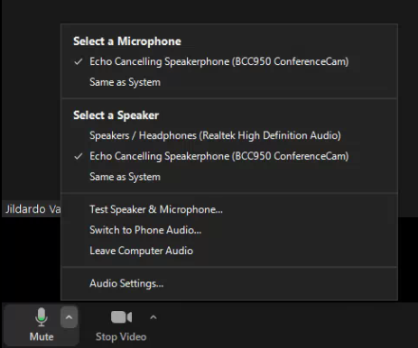

Under the ‘Microphone’ tab in your meeting,

Select ‘Echo Cancelling Speakerphone

(BCC950 ConferenceCam)’ for

microphone and for speaker. -------🡪

# Using Microsoft Teams:

Click on the 3 dot icon next to the ‘Share’ icon.

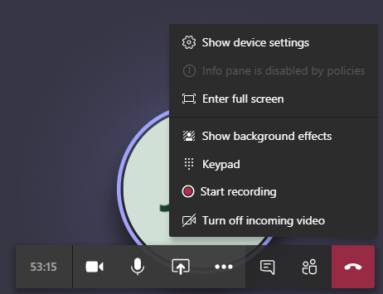Choose ‘Show device settings’

Under the camera selection, select ‘BCC950 ConferenceCam’

Under the microphone and speaker selections,

select ‘Echo Cancelling Speakerphone (BCC950 ConferenceCam)’.

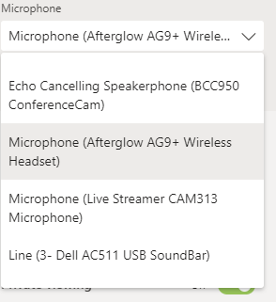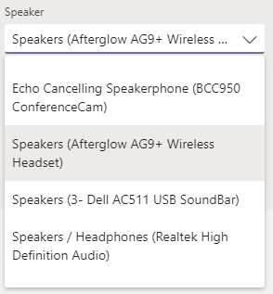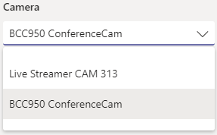

# Remote control:

To zoom in or out click on the (+) or (-) signs.

Use the directional keys to adjust camera position and angle.

# Camera Main Panel

To zoom in or out click on the (+) or (-) signs.

Use the directional keys to adjust camera

position and angle.